Answers to 2010 TJC H2 Chemistry Prelim P3

1 | (a) | (i) |  | - Standard enthalpy change of combustion is the heat evolved when one mole of the substance is completely burnt in oxygen at 298 K and 1 atm.
 |  | (ii) |  | •• (1 mark working, 1 mark answer)  ΔH_{c}  C₈H₁₈(l) + 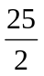O₂(g) → 8CO₂(g) + 9H₂O(l)  -269  8(-394) + 9(-286)  8C(s) + 9H₂(g) + O₂(g)  By Hess’ Law,  ΔH_{c} = 269 + 8(-394) + 9(-286) = - 5460 kJ mol⁻¹  - Heat evolved per gram of octane = 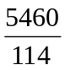 = 47.9 kJ g⁻¹
 |  | (iii) |  | •• (1 mark working, 1 mark answer)  CH₃OH(g) + O₂(g) → CO₂(g) + 2H₂O(g)  Bonds broken: 3C-H, C-O, O-H, O=O  Bonds formed: 2C=O, 4O-H  ΔH_{c} = 3(410) + 360 + 460 + (496) – 2(740) – 4(460) = -526 kJ mol⁻¹  - Heat evolved per gram of methanol = 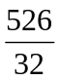 = 16.4 kJ g⁻¹
 |  | (iv) |  | • As weight considerations are usually important is racing car, one advantage of using petrol (octane) is that it produces more heat energy per gram of fuel.
 | (b) | - As B is achiral, it does not contain a chiral centre or it has a plane of symmetry.  - B undergoes elimination with alcoholic potassium hydroxide to form alkenes C, D and E.  - Alkenes C and D undergo oxidation with hot concentrated acidic potassium manganate(VII).  ••••• (1 mark for each correct structure)  C and D are geometrical isomers:  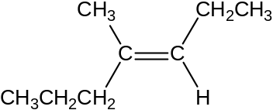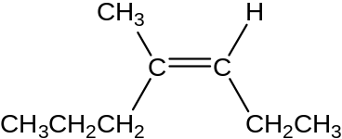  E: 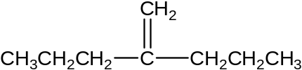  B: 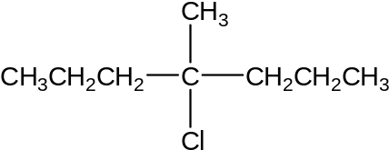  A: 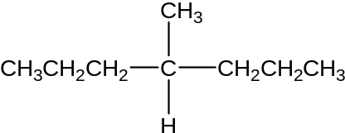 [8 marking points, maximum 7 marks]
 | (c) | (i) | - CH₃CH₂OCH₂CH₃
 |  | (ii) | • CH₂=CH₂
 |  | (iii) | •• (1 mark for each step)  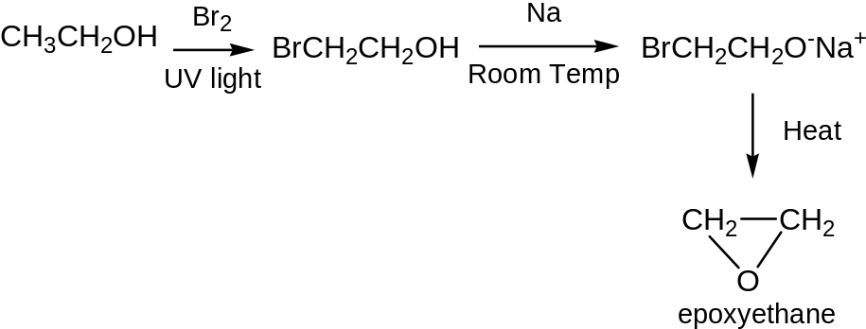
 |  | (iv) | - Possible answers:  - As the first step involves free radical substitution, a mixture of bromo-substituted products will be obtained and BrCH₂CH₂OH may not be the major product.  - BrCH₂CH₂O⁻ can react with another BrCH₂CH₂O⁻ to give BrCH₂CH₂OCH₂CH₂O⁻ and other straight chain products.  - Epoxyethane has a highly strained three-membered ring which makes it reactive/unstable.
 |  |  | [20 marks]

2 | (a) | (i) |  | • Le Chatelier’s Principle states that when system at dynamic equilibrium is subjected to a change which disturbs the equilibrium, the system will respond in such a way so as to counteract the effect of the change (to re-establish equilibrium).
 |  | (ii) |  | • Catalyst is added to speed up the reaction and to achieve equilibrium at a shorter time.  • Only atmospheric pressure (or low pressure) is used as by Le Chatelier’s principle, a low pressure would favour the forward reaction as to produce more number of moles of gaseous products thus improving the yield.  • A high temperature of 300 °C is used as the forward reaction is endothermic and by Le Chatelier’s principle, a high temperature would favour the forward reaction as to absorb heat, thus increasing the yield of the products.
 | (b) | (i)  PC₇H₈ . PH₂⁴  PC₇H₁₆  • K_{p} =
 |  | (ii) | 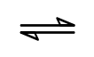  Let x be the initial pressure of C₇H₁₆ and P be the total pressure at equilibrium.  C₇H₁₆ (g) C₇H₈ (g) + 4H₂ (g)  Initial pressure/ atm x 0 0  Change in pressure/atm -0.9x +0.9x +3.6x  Final pressure/ atm 0.1x 0.9x 3.6x  0.1x + 0.9x + 3.6x = P  4.6x = P  x = 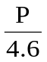  • Partial pressure of C₇H₁₆ = 0.1 ()  = 0.0217P atm  • Partial pressure of C₇H₈ = 0.9 ()  = 0.196P atm  • Partial pressure of H₂ = 3.6 ()  = 0.783P atm  K_{p} = 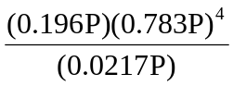= 1  • P = 0.737 atm
 | (c) | (i) | • Electrophilic substitution  • Step 1: Generating the electrophile, NO₂⁺  HNO₃ + H₂SO₄ H₂NO₃⁺ + HSO₄⁻  base acid protonated nitric acid  H₂NO₃⁺ NO₂⁺ + H₂O  nitronium ion  Acceptable answers include:  HNO₃ + 2H₂SO₄ NO₂⁺ + 2HSO₄⁻ + H₃O⁺  HNO₃ + H₂SO₄ NO₂⁺ + HSO₄⁻ + H₂O  • Step 2: Electron-rich benzene attacks the NO₂⁺ electrophile  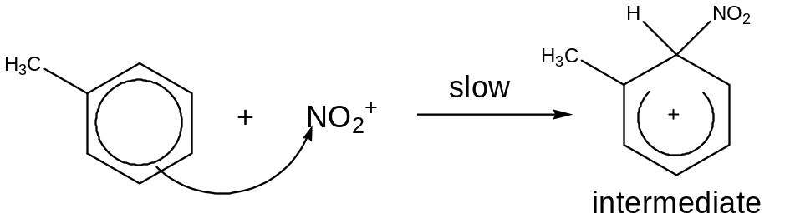  • Step 3: Proton expulsion followed by regenerating step  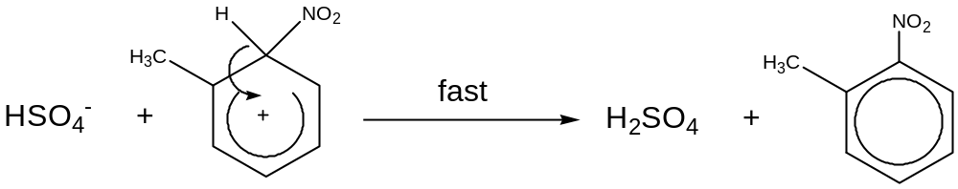
 | (d) | (ii) | 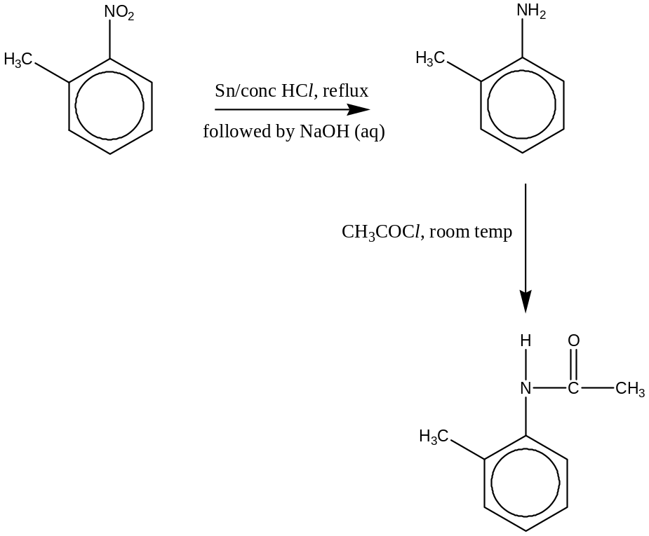  (1m for intermediate structure; 2m for reagents and conditions in each step)
 | (e) |  | E^{θ}_{BrO3−/Br2} = +1.48 V  E^{θ} _{Zn2+/Zn} = -0.76 V  E^{θ}_{Br2/Br−} = +1.07 V  E^{θ} _{H+/H2} = 0.00 V  • Since E^{θ}_{BrO3−/Br2} is more positive than E^{θ} _{Zn2+/Zn}, BrO₃⁻ will reduced to Br₂ and Zn will be oxidised to Zn²⁺.  OR  E^{θ}_{cell} = 1.48 – (-0.76) = +2.24 V  Since E^{θ}_{cell} > 0, reaction is feasible  • 2BrO₃⁻ + 12H⁺ + 5Zn → Br₂ + 6H₂O + 5Zn²⁺  • Zinc will be oxidized to form Zn²⁺ while colourless BrO₃⁻ will be first reduced to brown Br₂. Zinc metal gets smaller/thinner as it is being oxidised.  Since E^{θ}_{Br2/Br−} is more positive than E^{θ} _{Zn2+/Zn}, Br₂ will reduced to Br⁻ and Zn will be oxidised to Zn²⁺.  OR  E^{θ}_{cell} = 1.07 – (-0.76) = +1.83 V  •  Since E^{θ}_{cell} > 0, reaction is feasible  Br₂ + Zn → 2Br⁻ + Zn²⁺  Brown Br₂ is further reduced to colourless Br⁻.  OR  Since E^{θ} _{H+/H2} is more positive than E^{θ} _{Zn2+/Zn}, H⁺ will reduced to H₂ and Zn will be oxidised to Zn²⁺.  OR  E^{θ}_{cell} = 0.00 – (-0.76) = +0.76 V  •  Since E^{θ}_{cell} > 0, reaction is feasible  H⁺ + Zn → H₂ + Zn²⁺  Effervescence of H₂ gas observed.
 |  |  |  |  | 3 | (a) | (i) | • Transition elements are d-block elements which form at least one ion with a partially filled d subshell.
 |  |  |  |  |  |  | (ii) | - 1s²2s²2p⁶3s²3p⁶3d⁵4s¹
 |  |  |  |  |  |  | (iii) | - +2, +3 & +6
 |  |  |  |  |  | (b) | (i) | • The N and O atom can each donate a lone pair of electrons to Cr³⁺ ion.  - Dative /coordinate bond
 |  |  |  |  |  |  | (ii) | • 6 & Octahedral
 |  |  |  |  |  | (c) | (i) | • Red /Orange
 |  |  |  |  |  |  | (ii) | - For chromium complex, the chromium ion has partially filled 3d orbitals.  - In the presence of ligands, the five 3d orbitals are no longer degenerate and split into two energy levels due to the repulsion of the metal ion and the ligands.  - When an electron is promoted from lower energy d orbital to higher energy (d-d transition), an amount of energy has to be absorbed in the visible region of the electromagnetic spectrum. The colour observed is complement to the light absorbed.
 |  |  |  |  |  | (d) |  | • It is produced in the body/so it should not be toxic/stable
 |  |  |  |  |  | (e) | (i) | - 6CrO₂ + 10H⁺ → 4Cr³⁺ + Cr₂O₇^{2─} + 5H₂O  - Cr₂O₇^{2─} + 14H⁺ + 6Fe²⁺ → 2Cr³⁺ + 7H₂O + 6Fe³⁺
 |  |  |  |  |  |  | (ii) | No of moles of Fe²⁺ = 10.0 x 0.02/1000 = 2.00 x 10⁻⁴  Cr₂O₇^{2─}≡ 6Fe²⁺≡ 6CrO₂  No of moles of CrO₂ = 2.00 x 10⁻⁴  Mass of CrO₂ = 2.00 x 10⁻⁴ x 84 = 1.68 x 10⁻² g.  [working:1 mark, answer:1 mark, ECF if correct calculations is done based on wrong equations written in (e)(i)]
 |  |  |  |  |  | (f) | (i) | - N₂(g) and H₂O(g)  • (NH₄)₂Cr₂O₇ → Cr₂O₃ + N₂ + 4H₂O  [Oxid no: N(-3) Cr(+6) Cr(+3) N(0) ]  (Gases formed are colourless and odourless, so they cannot be NH₃ or NO₂. Since oxidation state of Cr decreased from +6 to +3, oxidation state of the other element must have increased. In the reactant, H has O.S. of +1 and cannot be oxidised further. Hence, N could have been oxidised from -3 to 0 oxidation state, forming N₂. The other gas formed is H₂O.)
 |  |  |  |  |  |  | (ii) | - NH₃ gas evolved turns moist red litmus blue and orange dichromate(VI),Cr₂O₇²⁻, solution turns yellow as chromate(VI), CrO₄²⁻ is formed.  - NH₄⁺ + OH⁻ → NH₃ + H₂O  - Cr₂O₇²⁻ + 2OH⁻ → 2CrO₄²⁻ + H₂O

4 | (a) | (i) | • A buffer solution is one that can resist changes in pH upon additions of small amounts of acid or alkali.
 |  | (ii) | • On adding H⁺, C₅H₇O₄CO₂⁻ mainly from the salt reacts with it to form C₅H₇O₄CO₂H . This helps to remove the excess H⁺ and hence maintain pH.  C₅H₇O₄CO₂⁻ + H⁺ C₅H₇O₄CO₂H  • On adding OH⁻, C₅H₇O₄CO₂H reacts with it to form water. This helps to remove the excess OH⁻ and hence maintain pH.  C₅H₇O₄CO₂H + OH⁻ C₅H₇O₄CO₂⁻ + H₂O
 |  | (iii) | pH = pK_{a} + lg [salt] = - log(7.4 x 10⁻⁴) + lg (0.002/0.050) = 3.43  [acid] (0.001/0.050)  (• correct substitution in formula; • final answer)
 | (b) | (i) | • •Carboxylic acid, primary amine, substituted amide or amide and ester.
 |  | (ii) | • Add NaHCO₃/Na₂CO₃  • Effervescence of CO₂ which gave a white ppt with limewater OR  add PCl₅; white fumes of HCl evolved OR add Na metal; effervescence observed  Note : There is no simple test for esters (acid hydrolysis and test for acid or alcohol is not acceptable)
 |  | (iii) | •  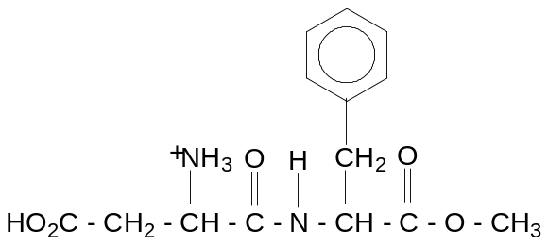
 |  | (iv) | ••  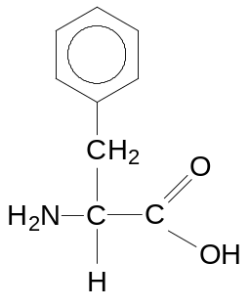  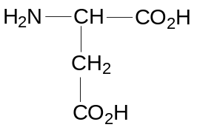
 |  | (v) | • The R group which contains –CO₂H group, can interact with other polar R groups (containing –OH / C=O or –CH₂CO₂H) via hydrogen bonding.  Or when ionized to –CH₂CO₂⁻ in aqueous medium can form ionic bonds / electrostatic attraction with cationic R groups e.g. those with –⁺NH₃  •The R group which is non-polar can interact with other non-polar R groups via induced dipole-induced dipole interaction/vdw forces.
 | (c) | (i) | • Add bromine water.  • White precipitate and decolourisation from reddish brown to colourless solution occurs for salicylic acid. There is no observable change for benzenecarboxylic acid.  Or  - Add neutral FeCl₃  - Violet colouration and buff ppt occurs for salicylic acid while only buff ppt for benzenecarboxylic acid.
 |  | (ii) | 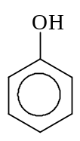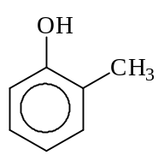  • CH₃Cl  AlCl₃  • KMnO₄ / H⁺  Heat  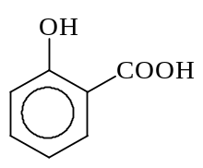  Or  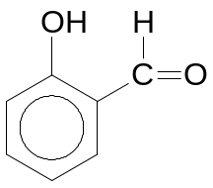  • HCOCl  AlCl₃  • KMnO₄ / H⁺  Heat
 | (d) | ••  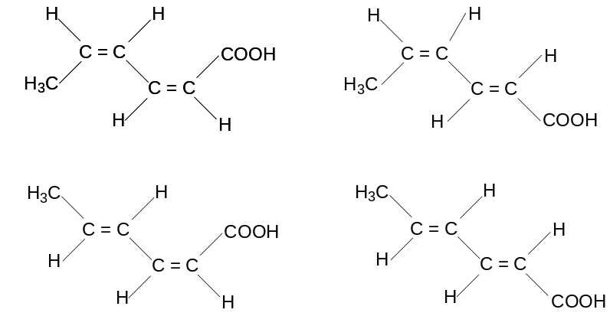

5 | (a) | (i) | - Na₂O has a giant ionic structure and consists of strong ionic bonds. The O²⁻ ion reacts with water to give a strongly alkaline solution. pH = 13  - Na₂O + H₂O → 2NaOH  - SiO₂ is a covalent oxide with a giant molecular structure. Strong covalent bonds are present between its atoms. It is insoluble in water. Hence pH remains as 7.  - P₄O₁₀ (or P₄O₆) is a covalent oxide with a simple molecular structure. Weak van der Waals’ forces are present between the molecules. There are energetically accessible vacant d orbitals for dative bonding with water molecules. P₄O₁₀ (or P₄O₆) dissolves readily in water to give an acidic solution of pH 2.  - P₄O₁₀ + 6H₂O → 4H₃PO₄ OR P₄O₆ + 6H₂O → 4H₃PO₃  - All pH correct
 |  | (ii) | - Silicon dioxide has a giant molecular structure while P₄O₁₀ (or P₄O₆) has a simple molecular structure.  • Melting of silicon dioxide involves breaking of strong covalent bonds, while melting of P₄O₁₀ (or P₄O₆) involves breaking of weak van der Waals’ forces. Since van der Waals’ forces are weaker than covalent bonds and require less energy to overcome. Hence the melting point of P₄O₁₀ (or P₄O₆) is lower.
 |  | (iii) | - BeO + 2H⁺ → Be²⁺ + H₂O  - BeO + 2OH⁻ +H₂O → Be(OH)₄²⁻
 | (b) | (i) | • M(NO₃)₂ (s) → MO (s) + 2NO₂ (g) + ½O₂ (g)
 |  | (ii) | - 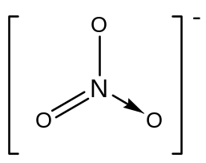  - Trigonal planar
 |  | (iii) | - Ionic radii of Mg²⁺ 0.065nm, Ca²⁺ 0.099nm, Sr²⁺ 0.113nm  - Ionic radius increases down the group. The charge density and hence polarising power of M²⁺ decreases and nitrate is polarised to smaller extent.  - Thermal stability increases from magnesium nitrate to strontium nitrate.
 |  | (iv) | pV = nRT  - number of moles of O₂ = 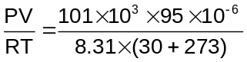= 3.81 x 10⁻³ mol
 |  | (v) | number of moles of M(NO₃)₂.xH₂O = 0.00762 mol  number of moles of H₂O = 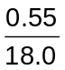= 0.0306 mol  - x = 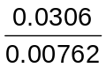= 4  - M_{r} of M(NO₃)₂ = 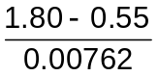= 164.0  A_{r} of M = 164.0 – 2[14.0 + 3(16.0)] = 40.0  - M is calcium  [the hydrate is Ca(NO₃)₂.4H₂O]

